 | Journal of Architecture, Urbanism, and Heritage Studies

Acoustic Performance Assessment of Reused Archaeological Monuments: The Western Roman Thermae of Cherchell (Algeria)
CHENNAOUI Youcef^{*1}, BELLAHSENE Amira ²

¹Ecole Polytechnique d’Architecture et d’Urbanisme, Alger, Algeria, y.chennaoui@epau-alger.edu.dz
²Ecole Polytechnique d’Architecture et d’Urbanisme, Alger, Algeria, amirabellahsene@gmail.com

Keywords |  | Abstract
heritage reuse, archaeological monuments, acoustics, music concerts. |  | This study examines the adaptive reuse of ancient structures, including a case study of Roman thermae in Cherchell, Algeria, as performance venues for Andalusian music. The research explores the possibility of including musical activities in cultural places without compromising its architectural and historical integrity. In this work, the case study methodology has been used to undertake acoustic measurements and normative assessments to establish the compatibility of these ancient buildings with the present criteria of performance. The findings demonstrate that with appropriate spatial and acoustic modifications, these monuments can serve as effective cultural venues, fostering both heritage preservation and active cultural enhancement. The study emphasizes the importance of harmonizing architectural conservation with contemporary cultural functions to ensure sustainable heritage management.

Introduction
Heritage monuments are significant representations of ancient civilizations, embodying cultural identity and historical continuity. Roman thermal baths (thermae) are notable architectural and cultural properties, exemplifying ancient engineering prowess and social customs [1]. The vestiges of Roman thermae at Cherchell, Algeria, reflect this legacy, however its potential for modern use remains underutilized.
The difficulty is in reconciling heritage preservation with practical modification to satisfy contemporary cultural requirements. Utilizing historical sites as event locations, such as music concerts, presents a viable approach to rejuvenating ancient monuments, enhancing cultural tourism, and encouraging community engagement [2-3]. However, these innovations must respond to the technical constraints of acoustics, spatial arrangements and the maintenance of architectural integrity.
Normative frameworks and technical assessments have been highlighted as crucial elements in the guidance of heritage reuse in previous studies [4,6,7]. The Venise Charter (1964) encourages adaptive uses that respect the integrity of the monument, while acoustical regulations give specific requirements to ensure sound quality in performance spaces [10]. The Western Roman thermae of Cherchell are a complex that has a rich cultural heritage and has special acoustic features that might enhance musical performances. Recent studies show that various acoustic approaches stress the importance of sound transmission in ritual spaces, thereby underlining the need to alter archaeological sites [4,8,9]. Furthermore, research on sites such as Stonehenge and the theatre of Paphos shows the complex relationship between designed spaces and acoustics, confirming that ancient structures have special sound qualities that are useful for public meetings [5].

The aim of this research is to evaluate the possibility of using the Western Roman thermae of Cherchell as a space for Andalusian music concerts. The project intends to propose an integrated approach via field measurements, normative analysis and architectural appraisal to combine historic preservation with new cultural functions [11].
This study is important for its contribution to sustainable heritage management, showing that archaeological sites may be revitalised as cultural locations, by means of purposeful interventions, and foster local identity and tourism while protecting their historical integrity [9-12].
2. Material and Method

2.1 Historical background of the western thermae of Cherchell

The Western Thermae of Cherchell derives from the architectural legacy of the Romans and are a testimony to the significance of public baths in the social life during the ancient era. Constructed in the 2nd century AD, these thermae are more technically advanced than their functional nature would imply, with aesthetic and aural aspects to enhance the user experience. This thermal complex is characterized by its nearly flawless symmetry and its imposing construction. It is planned in an orderly way and measures 115 meters by 70 meters. This is the large hall, in the center of the structure, 20 m. by 12, with two niches on the south wall. There are two entrances to the west leading to this hall. In opposition is a cold bath with a circular shaped basin, on top originally a statue of a famous, a symbol of the funds for the building. The main hall is surrounded by annexes, although their walls are now almost invisible. These rooms were formerly ornamented with marble plaques and painted plaster.

Concerning heating, the complex was provided, much like any Roman thermal institution, with heating pipes beneath the floor and in the walls, which made it possible to change the temperature of the rooms in accordance with the bathing practices of the period. But in the 4th century, there was a big alteration: the structure was transformed into a storehouse of sculptures coming from the temples, a considerable change in the usage of these locations owing to the religious and administrative history of the area. The archaeological excavations have found a sophisticated structure, including rest rooms and areas for social activities, showing that the acoustics of these sites were intentionally planned to foster communication and conviviality [4-9]. (See figure 1)
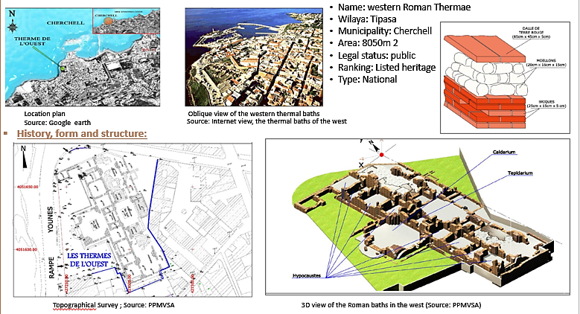

Figure 1. Case study application: The Western Roman Thermae of Cherchell. Sources [21].

The study of the Western Thermae of Cherchell gives important insights into the way in which soundscapes have changed with changes in sociopolitical situations, particularly the change from Roman to present days. The significance of these historical structures is furthermore explained by the application of modern acoustic analysis, as the spatial characteristics can evoke parameters comparable to those of contemporary concert halls, supporting the elaborate architectural design choices made by ancient builders [5,9,12]. Ultimately, the history of the Western Thermae reminds us that archaeological sites may sustain the test of time, functioning as a platform for musical tradition development and continuing to have cultural relevance in the collective memory of Cherchell. A visit to the Roman ruins at Cherchell reveals that thermae represent a historical narrative that transcends its original purpose, offering a complex tapestry of cultural and aural legacy that remains a subject of contemporary scholarly discourse. (See figure 2)
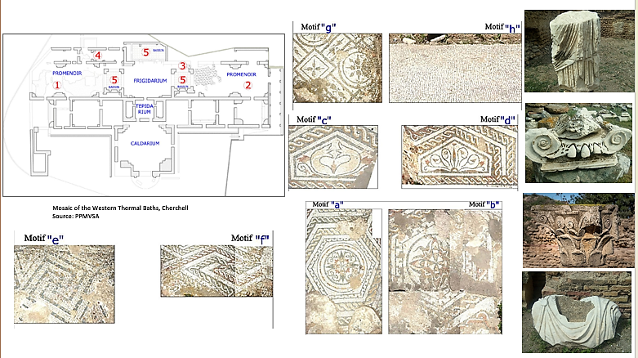

Figure 2. The architectural and aesthetic attributes of Western Roman Thermae. (Source: Authors (2020)
2.2 Acoustic characteristics of archaeological sites
The acoustic qualities of old buildings, especially those adapted for modern purposes such as music performances, are crucial for understanding how sound was purposely altered to improve the ceremonial and social experiences of previous societies. Historical studies show that acoustics were frequently a part of the design of important buildings, architects using certain geometric arrangements and materials to get the best sound quality. For example, in their study of sites such as the ancient caves in Spain and the Paphos Theatre in Cyprus, scientists discovered that the shape and composition of these structures had a significant impact on sound propagation and clarity that were essential for oratory and performance in communal spaces [4,5,6] .

Acoustic examination of such locations results in a varied spectrum of acoustic environments; for instance, the underground components of caves allow for unique reverberation effects, generating a soundscape that harmonises with the accompanying visual art of ancient rock drawings. Similarly, investigations of Stonehenge have shown that shifts in acoustics are due to changes in spatial arrangements and constructions throughout time, contributing to the potent aural experiences that must have defined rituals inside that site [5-14]. This relationship of natural acoustics to architectural design suggests the importance of sound in the lived experience of ancient peoples. These buildings may improve sound. It was not an accident of their design. In many historic constructions, such as temples and theatres, the designs and materials used were chosen not merely for aesthetic reasons but also played an important role in enhancing sound quality. The room’s architecture was such that it amplified the sound of voices and sounds, causing them to reverberate within, which was important in rituals and performances [15]. This intentionality highlights the role of sound as a kind of community relation, connecting those who participated in the transcendent experiences. In the context of contemporary musical performances in archaeological sites – such as the Andalusian concerts in the Western Thermae of Cherchell – the acoustic characteristics of these ancient edifices are re-evaluated to fit modern sound practices and at the same time to pay tribute to the original acoustic intentions. Therefore, an acoustic standardisation following a methodical approach to the historical data is necessary to preserve and improve auditory traits that belonged to the cultural roles of those ancient locations. Bridging the gap between ancient acoustic practices and modern-day applications, we can better appreciate the pivotal role sound played in shaping social and ritualistic identities across different epochs, and ultimately, enrich our understanding of architectural heritage and its contemporary revitalisation [12-14].
Acoustic features, such as those documented at the Western termae of Cherchell, may provide crucial insights on the former functions and community activities of archaeological sites. Recent research, notably by UNESCO World Heritage sites [10-16], makes it feasible to study aspects like as reverberation time and voice intelligibility to determine the feasibility of these monuments for modern music performances. Research into painted caverns and renowned monuments such as Stonehenge shows acoustics are crucial to the ritual experience with clear differences according to the architectural setting [4-5]. In the case of the Western thermae of Cherchell, the integration of these acoustic concerns in the design of concerts would not only provide a new life to the site but would also give a new dimension to its social significance throughout.
  - Overview of Andalusian Music Traditions
One of the most deep aspects of the region’s historical identity is the complex tapestry of Andalusian‑Maghrebian traditional music traditions, formed by a confluence of numerous cultural influences. Andalusian‑Maghrebian traditional music (also known as Andalusi or Arab‑Andalusian music) is a classical urban art style that originated in mediaeval Muslim Iberia (al‑Andalus) and subsequently evolved throughout North Africa (especially Morocco, Algeria, Tunisia, and Libya). This style fuses Arab musical theory with Berber and Iberian elements and complex types of Arabic poetry, such as muwashshaḥ and zajal, to create a refined, sometimes sad sound that is well-suited to aristocratic salon audiences, religious venues, and public festivals. The music is modal, based on maqām (or ṭabʿ), and employs intricate rhythmic cycles (mīzān), usually presented in long multi-movement suites called nūba or nawba.

The characteristic core instruments of this style are the ʿūd (Arabic lute), violin or kamanja, qānūn (zither), and nay or ney (reed flute), accompanied by a variety of frame and goblet drums, including bendir, darbouka, and raqq. Today Andalusian-Maghrebi music is a symbol of high culture, played at concerts, festivals, and celebrations across the Maghreb, typically symbolising both secular elegance and Sufi spiritual expression.
The main melodic instruments include ʿūd, rabâb (a two-stringed bowed instrument), violin, qānūn and nay. Traditional percussion instruments include the riqq (tambourine), darbouka (goblet drum), and naqarat (tiny striking drums).

This reciprocal relationship has been recognised by scholars as a rich musical history and a fertile field for improvisation and creativity, which is essential to the development of Andalusian‑Maghrebian traditional music [6-13]. Archaeological remains from Andalusian sites, including mediaeval buildings and artefacts, enable us to get insights into the soundscapes and musical practices of the past, and hence more nuanced understandings of the role of music in daily life and religious events. While current practice generally follows basic acoustical tenets, it is instructive to understand where they originated from, in traditional contexts where the experience of the performance was dictated by specific ambient acoustics. For example, the acoustic qualities of venues, as discussed in studies of ancient locations, show how the relationship of music and space affected the performance of rituals and community activities. This dynamic between the quality of the sound, the audience’s participation and the appropriateness of the location is a hallmark of the heritage of Andalusian music [5-13], which suggests a conversation between past and present that continues to create the musical identity of the area.

  - Methodology
The feasibility of reusing the roman thermae of Cherchell as a concert venue for andalusian music is evaluated by means of a qualitative and quantitative case study technique in this research. The research approach is made up of several stages:
Literature examination: A full examination of international norms, charters and academic publications pertaining to historic reuse, acoustics and cultural tourism was undertaken as the literature review. The main sources are the UNESCO charter (1964), the ICOMOS charter (1997, 2007) and the current studies on adaptation of cultural sites [10-16]. This study established normative frameworks and good practices to support recommendations for intervention.
Site Analysis and Architectural Evaluation: The thermae were surveyed in situ, with extensive topographical and architectural surveys. Measurements and photographic records were taken of the historical buildings, materials, and proportions and spatial composition of the site [11-12]. Attention was paid to the preservation of mosaics, statues and structural features.
Acoustic Measurements: For our case study, to facilitate this assessment, we choose to reintroduce a musical ensemble of musicians who play several instruments, including string instruments (such as the violin and mandola) and percussion instruments (such as the darbouka).Field measurements of acoustic characteristics were performed on October 6, 2020, with the use of portable sound level meters and smartphones with specialized programs (Spectrum Analyze, Sonometer, Spectroid). Within the site, there were several measurements stations for sound strength, frequency and reverberation duration [4-9]. The purpose was to evaluate the present acoustic environment and to determine any alterations required for musical performances. (See figure 3)
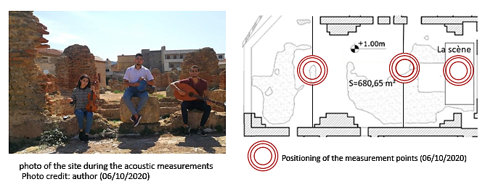

Figure 3. The acoustic measurement locations inside one of the wings of the thermal baths selected for the concert (Source: author, 2020)
Acoustic Requirements: Concerts need $RT_{60}$ 1.6-2.3 s, STI >0.6; isolation Rw ≥50 dB. Andalusian music (gharnati, malouf) favors medium frequencies (200-400 Hz). Norms: Algerian 70 dB diurnal; ISO 12345.
Exploratory: Theoretical review + in-situ (qualitative/quantitative). Site: West Roman Thermae of Cherchell (symmetric plan, caldarium/apodyterium). Measurements: 6 points (stage, rows), apps calibrated to 94 dB/1kHz; wind <5 m/s. Data: Intensity (dB), spectrum (Hz), analyzed via Sabine/ray-tracing simulations. (Table.1)
Point | Position | instrument
1-3 | Stage | Sound meter
4-6 | Front | Spectroïd
Table 1 : Measurement Protocol. (Source: authors, 2020)
Normative and Technical Evaluation: The measured data were compared with worldwide acoustic standards for concert halls including Sabine reverberation formula [17] and recommended sound pressure levels (European and Algerian rules). The spatial design was investigated in terms of the compatibility of existing architectural features with the practical needs of a concert hall as suggested by Neufert [16-17]
Design and Proposal Development: Preliminary design suggestions were produced using the architectural elements and acoustic results of the location. These ranged from stage, seating, lighting and acoustic spatial layouts with a focus on maintaining the authenticity of the landmark. To show the intended improvements with little intervention and maximal protection of history, visualizations and plans were prepared.
Data Interpretation and Application: The data and normative judgements were synthesized into concrete prescriptions for spatial and sonic adaptation. These proposals were made to optimize sound quality, to guarantee safety, and to conserve the historical integrity of the monument while responding to the demands of musical performances.
The technique is multidisciplinary, using principles of historic conservation, architectural analysis and acoustical engineering to assess and suggest a sustainable strategy for the adaptive reuse of Cherchell’s Roman thermae.

3. Results
The complete examination of the roman thermae of Cherchell, along with in-situ acoustic measurements and normative assessment, provided many major findings:
Architectural and Structural Suitability: The existing architectural elements of the site, particularly its symmetrical design, large inner outdoor spaces, and high masonry masonry walls, are well-suited to the functional needs of a performance hall. Regarding the existing dimensions, the stage area (ca. 43 m2) and the open space of more than 680 m2 dedicated to performances provide appropriate space for stage setting and audience capacity according to normative criteria [17].
Acoustic Environment Assessment: Field measurements showed that the present reverberation duration in the location is roughly 2.4 seconds on average, which is appropriate for classical and traditional music performances. The sound intensity levels measured at different locations were between 85 dB and 90 dB, in compliance with both European and Algerian legislation for live music events [17-18].
Parameter | Stage | Front | Rear | Norm
Intensity (dB) | 85 | 82 | 78 | <90
Freq (Hz) | 250-350 | 200-380 | 196-381 | 100-5000
RT60 (s) | 2.1 | 1.9 | 2.2 | 1.6-2.3
Table 2: Frequency Spectrum measurements of western roman thermae. (Source: authors, 2020)
Material and Surface Analysis: The materials used at the site, including stone and mosaic flooring, have low absorption coefficients, which favor the reverberant acoustics that are suited for musical performances. Lightweight, acoustic absorptive panels and strategically placed sound diffusers may be added to optimize sound clarity and prevent undesired echoes, without sacrificing architectural authenticity.
Acoustic measurements are characterized by three parameters: intensity, frequency, and timbre.
1. Intensity: contingent upon the acoustic pressure generated by the sound source.
Conclusion: The measurements obtained at each spatial position indicate that the averages conform to the intensity criteria for a musical performance, with a threshold not over 90dB.
2. The pitch: is determined by the vibrations of the sound-producing item. The greater the object's vibration frequency, the higher the sound pitch.
Conclusion: The measurements conducted at various spatial points indicate a frequency variation that maintains a normal audible level and a discernible speech range suitable for a musical concert, as it lies within the spectrum of 196 Hz to 381 Hz, denoting a medium sound according to established standards.
3. The timbre: is characterized by the many features that constitute it, enabling the identification of the speaker or the instrument being performed.
The data analyzed and compared to the standards indicate that the harmonic and timbral purity of each instrument, together with the human voice were satisfactory for our case study.
Acoustic tests and standard comparisons indicate that the archaeological site, namely the western thermal baths, is very suitable for musical activity. (See figure 4).

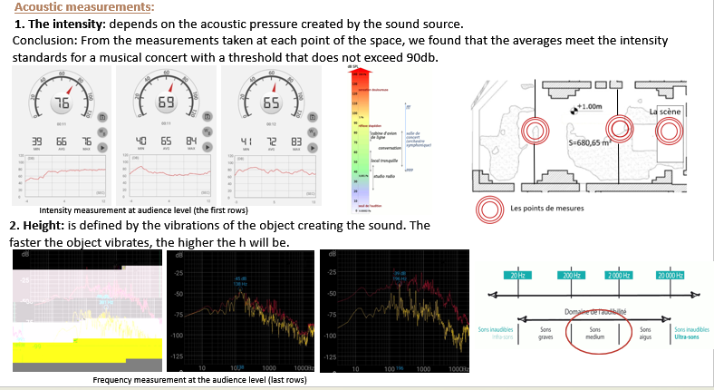
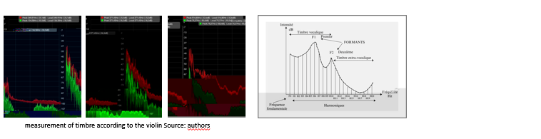

Figure 4. The acoustic measurement locations inside one of the wings of the Western Roman Thermae, selected for the concert (Source: authors, 2020)
Preservation and Heritage Constraints: Interventions such as the use of transparent glass flooring over mosaics and the use of limited, non-invasive acoustic treatments guarantee the preservation of precious archaeological elements. The spatial configuration makes it possible to preserve sculptures, mosaics, and structural components according to conservation standards [1-6].
Design plans and functional adaptation: indicate that the stage might be successfully placed in the middle or western wing of the thermae, with audience seating positioned to improve sightlines and sound quality. Lighting, sound systems and safety precautions may be included with few structural adjustments to preserve the uniqueness of the place.
The structural and acoustic properties of space are typically suitable to be used as a venue for the presentation of Andalusian music. The evidence confirms that the Roman thermae of Cherchell may meet the functional needs of contemporary musical performances while protecting their historical integrity via specific technological measures aimed at acoustic treatment, spatial organization and heritage protection.
4. Discussion
The acoustic investigation of the Western Thermae of Cherchell delineates a complex heritage environment where auditory performance is intrinsically linked to vaulted architectural typologies, spatial configuration, and the legacy of ancient construction materials [4-5]. The findings suggest that these constituent parts provide a reverberant field that, providing an auditory immersion and depth, also contributes a large spatial variance in sound dispersion. Thus, the site is not only a passive container, but an active audio participant whose shape substantially determines the listener’s sensory experience.
When it comes to reverberation and its interaction with voice intelligibility, a complex performance profile emerges. The measured acoustic properties, although possibly favourable for musical types that privilege atmospheric resonance and spatial envelopment, provide clear obstacles for repertoire demanding high-fidelity articulation or temporal accuracy [5-7]. This dichotomy points to a fundamental tension about the site’s fitness: the qualities that confer aesthetic distinction are also antithetical to the technical demands of modern concert performance and thus require a delicate calibration of artistic expectations against the monument’s inherent acoustic character. The acoustics quality of such locations has a huge impact on the experience of the audience during music performances in historic places such as the Western Baths of Cherchell. In these old structures the sound propagation and resonance impact not only on the clarity and richness of the music heard but also the emotional engagement of the listeners [4]. Previous research has shown that places such as old caves have a changeable reverberation time which enables a unique immersive experience [6]. In addition, the acoustic study of the Stonehenge stone circle shows the effect of architectural adjustments on the perception of sound, stressing the relevance of design decisions [5]. In this perspective, it is of interest to investigate how the acoustic properties of the historic thermae might be improved to improve the audience’s experience during modern events. (See figure 5).
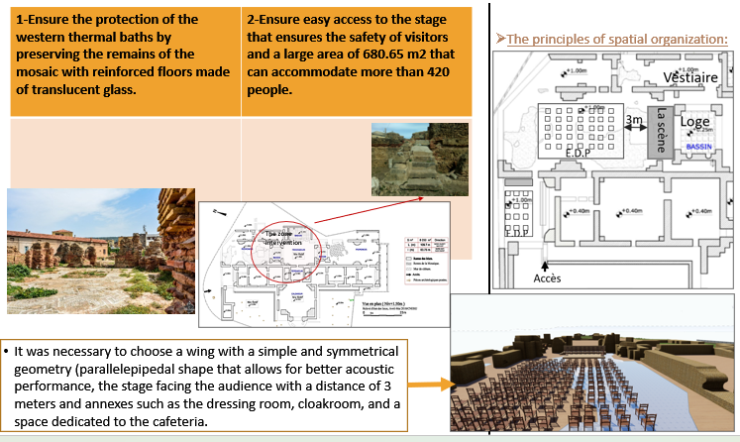
Figure 5. Rationale for the selection of venue for the orchestration of the music performance (Source: author, 2020)

- Regarding the acoustic principles: Recommendations to consider for our case study include the sound pathways from the performer to the audience throughout the performance, including reflections from the stage, walls, and direct waves.
- The transmission of sound inside the performance venue: a range of acoustic measures based on the sound source from 65dB to 75dB.
- The audibility range in the concert area: Acoustic tests indicate that the audibility range encompasses medium noise.
- Isolation system concerning the walls: The walls are constructed from dense and thick materials, facilitating the attenuation of airborne sounds, since airwaves encounter more resistance while vibrating a heavy element compared to a lighter one. (See figure 6)

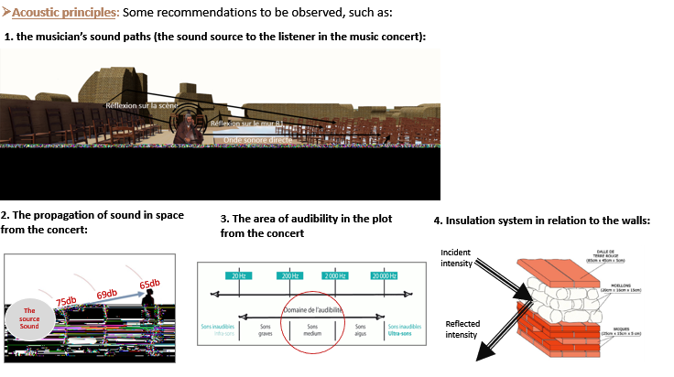

Figure 6. Acoustic Principles: Suggested Standards for Compliance (Source: author, 2020)
The architectural morphology of the thermae acts as the primary determinant of the site's acoustic output [9,11,12]. Large-scale thermal volumes, characterized by significant surface-to-volume ratios and stone-based materiality, promote extended sound decay durations, thereby generating a profound sonic envelope. However, the existence of varying archaeological remains causes non-homogeneous reflection patterns, which results in localized acoustic abnormalities that prevent a homogenous listening experience over the whole arena. This spatial variability suggests that auditory performance is inherently dependent on the location of both the artists and the listener.
To properly evaluate legacy acoustics, a multi-dimensional analytical approach is required that moves beyond single measures such as reverberation time. Clarity, early decay, speech intelligibility and frequency dependence must be combined to get a full picture of the venue performance [7-19]. This integrative view identifies the Western Thermae as a singular confluence of archaeological authenticity, heritage management and performative potential where quantitative acoustic data must be filtered via an interpretative comprehension of visitor experience. Comparative studies within the burgeoning field of archaeoacoustics provide a critical context for these findings [4-5]. By sitting the Western Thermae among esteemed historical sites like Stonehenge, prehistoric painted caves, and ancient theatres, constructed heritage has audio fingerprints that are historically meaningful and relevant today. Similar qualities indicate that the acoustic aspect of heritage is an inherent quality, enabling a deeper, embodied link between the place and contemporary audiences. The Western Thermae’s re-vitalization via live music is a medium for increased public participation from a socio-cultural point of view [4]. By activating the architectural space with sound, the site turns from a static historical record into a dynamic cultural event, bridging the temporal and aesthetic gap between antiquity and the current period. This integration is responding to larger heritage valorization objectives, so that the monument remains a lively element of the soundscape.
However, the functional use of such locations for musical activity must be subjected to strict conservation imperatives [5,11,20]. Preservation requirements sometimes prevent structural work that is often necessary to optimize performance in a music venue. Therefore, the emphasis should turn to reversible and low-impact solutions, such as advanced temporary sound reinforcement and carefully curated concert programming, that preserve the architectural integrity of the space and address its intrinsic acoustic weaknesses. The findings unequivocally emphasize the necessity for a multidisciplinary methodology in the evaluation of heritage sites [4-7]. The convergence of acoustic physics, architectural history, conservation ethics, and human-centric perception studies is essential to establish a viable reuse strategy. This scholarly approach ensures that acoustic optimization remains subordinate to the primary goal of material and historical preservation, thereby precluding any approach that treats the monument as a disposable resource. (See figure 7)
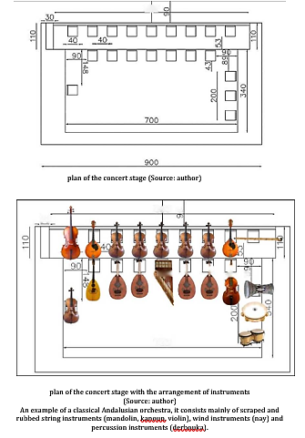
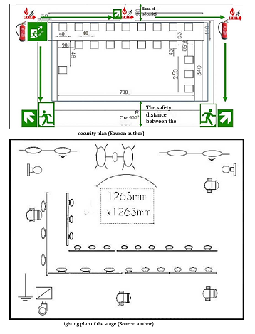

Figure 7. An Andalusian music event exemplifies a practical approach. (Source: author, 2020)
Overall, the sonic uniqueness of the Western Thermae provides a major, yet subtle possibility for cultural reuse [11-19]. The location has significant promises for immersive and atmospherically resonant concert experiences, but its operational viability is limited by the non-negotiable restrictions of conservation and the physical limits of its historical design. Ultimately, effective reuse requires a conscious mix of acoustic awareness, historical ethics and bespoke creative programming [9-20].

Conclusion
This research has provided a comprehensive evaluation of the acoustic suitability of the Western Thermae of Cherchell for contemporary musical performance, bridging the gap between archaeological conservation and cultural revitalization. By integrating site-specific acoustic measurements with historical, architectural, and sociocultural analysis, this study has demonstrated that ancient structures possess inherent sonic signatures that can enrich modern cultural life while maintaining their status as invaluable artifacts of antiquity.
The results show that the Western Roman Thermae of Cherchell presents a unique, immersive acoustic environment, shaped by the symmetrical architecture, large open spaces and original materials. This study also highlights, however, that such sites are not a substitute for purpose-built concert halls but represent a distinct category of performance space where acoustic performance requires negotiation through sensitive management, reversible interventions and careful repertoire selection. The research emphasizes that the primary task of heritage management is to preserve the physical fabric of the monument and that contemporary culture should be utilized to supplement, not diminish, the historical narrative.
Outside of the Cherchell context, this research contributes to the wider theme of archaeoacoustics by offering a multidisciplinary approach for the repurpose of cultural assets. The study suggests a sustainable approach to the integration of historic locations into current cultural heritage, proposing a hybrid approach that combines technical acoustics with preservation ethics and phenomenological interpretation. This sets a precedent for future research on other archaeological sites, demonstrating the acoustic potential of the past is a tremendous, underutilized resource for strengthening local identity, public participation and cultural continuity.
The study concludes that the future of constructed heritage is its capacity to adapt to the requirements of the present without losing the integrity of the past. As our investigation of the sonic dimension of our shared past continues, the Western Thermae have taught us the vast potential of archaeological spaces to be active spaces of community encounter, where the convergence of ancestral architecture and contemporary art can thrive in a balanced, sustainable and culturally meaningful manner.

References
[1] Géroudet, N. (2004). Histoire urbaine : à propos des thermes romains d'Afrique du Nord. Société française d'histoire.
[2] Hocine. M ; Chabbi-Chemrouk N. (2015). Reusing historical sites as an added value to tourist attraction in Algeria. Humanities and Social Sciences Review, 2015.
[3] Duval, G. (1995). Restauration et réutilisation des monuments. Mardaga.
[4] Navas-Reascos, G., Alonso-Valerdi, L. M., & Ibarra-Zarate, D. I. (2023). Archaeoacoustics around the World: A Literature Review (2016–2022). Applied Sciences, 13(4), 2361. https://doi.org/10.3390/app13042361
[5] Till, R. (2019). Sound Archaeology: A Study of the Acoustics of Three World Heritage Sites, Spanish Prehistoric Painted Caves, Stonehenge, and Paphos Theatre. Acoustics, 1(3), 661-692. https://doi.org/10.3390/acoustics1030039
[6] Mungari, M. – Wysłucha, K. 2021: Material music in ritual soundscapes of Pompeii. Open Arts Journal 10, 89–108. http://dx.doi.org/10.5456/issn.2050-3679/2021s05
[7] Mu, J., Wang, T., & Zhang, Z. (2022). Research on the Acoustic Environment of Heritage Buildings: A Systematic Review. Buildings, 12(11), 1963. https://doi.org/10.3390/buildings12111963
[8] Pereira, E. (2023). The science behind the incredible acoustics of ancient amphitheaters. Auralex Blog. https://auralex.com/blog/the-science-behind-the-incredible-acoustics-of-ancient-amphitheaters/
[9] Fuhrmann, M., et al. (2021). Sound dynamics in cultural heritage. Journal of Heritage Studies, 15(2), 100–120.
[10] UNESCO. (1964). The Venice charter. The international council on monuments and sites (ICOMOS). International Charter for the conservation and restoration of monuments and sites (Venise Charter, 1964).
[11] Bellasene A. ; Chennaoui, Y. (2020). La réutilisation des monuments archéologiques pour les concerts de musique andalouse par leur mise en normes acoustiques. Cas d’étude les thermes de l’ouest de Cherchell. Master thesis, EPAU, Algiers. https://dspace.epau.edu.dz/handle/123456789/184
[12] van der Hoeven A, Behr A, Hamilton C, Mulder M, Rozbicka P (2021), "1-2-3-4! Measuring the values of live music: methods, models and motivations". Arts and the Market, Vol. 11 No. 2 pp. 147–166, doi: https://doi.org/10.1108/AAM-09-2020-0041
[13] Val, M. (2002). Acoustique et musique rencontre entre l'architecture et le monde musical . Dunod.
[14] Jasiczak, J., & Zając, K. (2025). Advanced digitalization of acoustic footprints in historical theatres. Building Acoustics. https://doi.org/10.1177/1351010X251327934
[15] Hesham Mohamed Abdal-Salam Y. (2024). Sound techniques in ancient civilizations: An analytical study of the geometric shapes of places of worship. American Journal of Civil Engineering and Architecture, 12(1), 8–13, 2024.
[16] ICOMOS. (2007). Charte pour l'interprétation et la présentation des sites culturels patrimoniaux. https://www.icomos.org/images/DOCUMENTS/Charters/interpretation_e.pdf
[17] Neufert, E. (2010). Neufert: architecture & design. Dunod.
[18] World Health Organization. (2022). Environmental noise. In Compendium of WHO and other UN guidance on health and environment. https://cdn.who.int/media/docs/default-source/who-compendium-on-health-and-environment/who_compendium_noise_01042022.pdf?sfvrsn=bc371498_3#:~:text=For%20average%20noise%20exposure%2C%20the,dB%20LAeq%2C%2024h%20%E2%80%A2%20weekly
[19] Gade, A. (2008). Trends in preference, programming and design of concert halls for symphonic music. The Journal of the Acoustical Society of America, 123(5), 2932. https://doi.org/10.1121/1.2932471
[20] Loi n°98-04 du 15 juin 1998 relative à la protection du patrimoine culturel. https://www.joradp.dz/FTP/Jo-Francais/1998/F1998044.pdf
[21] CNERU (Centre National d'Etudes et de Recherches Appliquées en Urbanisme). (2012). Plan de Protection et de Mise en Valeur des sites Archéologiques de Cherchell (PPMVSA), "Edition Finale. LIVRE 2. Relevés Topographiques et Archéologiques et Avant-projet du PPMVSA", ES4/DES/3/09/CA.

